**10.3**

**What Is Cluster Analysis**

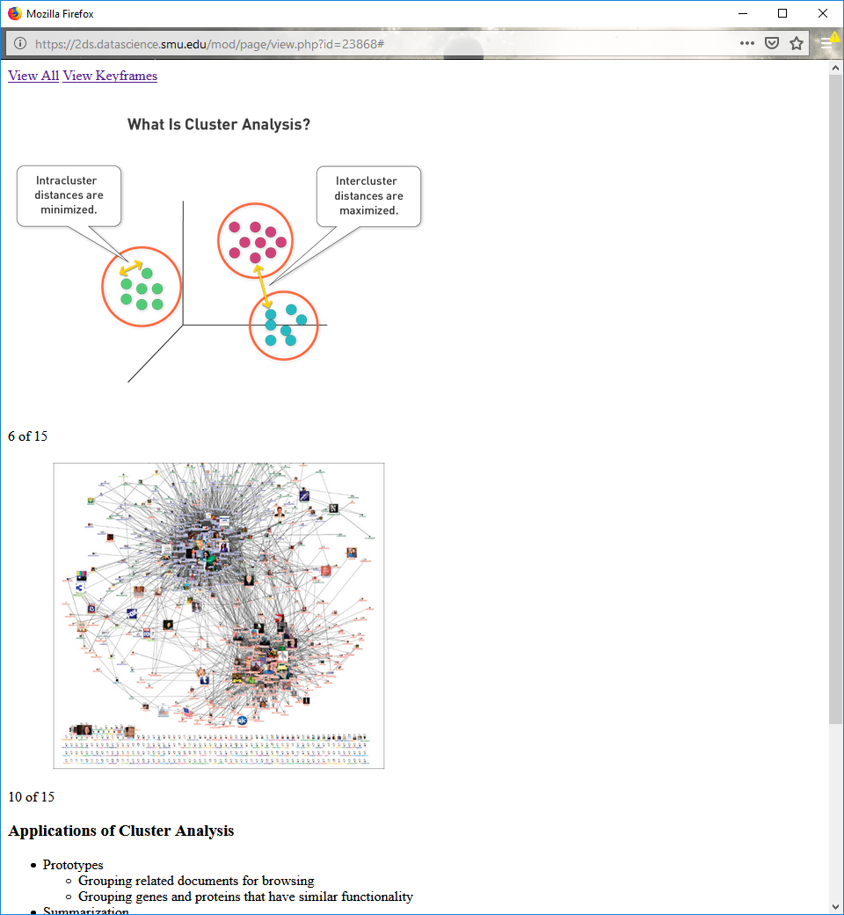



**Applications of Cluster Analysis**

Prototypes

Grouping related documents for browsing

Grouping genes and proteins that have similar functionality

Summarization

Reducing the size of large data sets (efficient PCA)

Quantizing values of data sets (efficient KNN)

**Self-Test**

Are these valid types of clustering?

1. Dividing students up alphabetically?

2. Partitioning a graph by cutting links?

**Partitional Clustering**

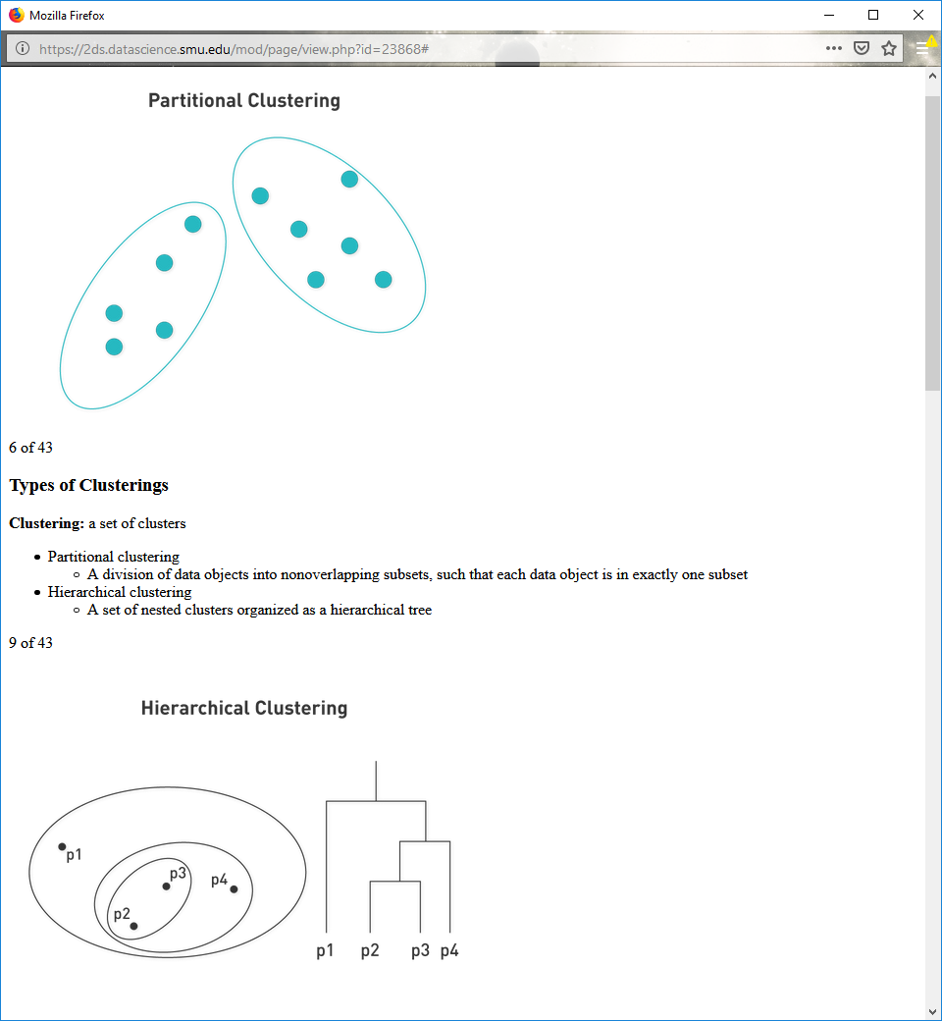

**Types of Clusterings**

**Clustering:** a set of clusters

**Partitional** clustering

A division of data objects into non-overlapping subsets, such that each data object is in exactly one subset

**Hierarchical** clustering

A set of nested clusters organized as a hierarchical tree

**Hierarchical Clustering**



**Types of Clusters**

Defining clusters can be ambiguous.

There are six categories of clusters:

Well separated

Center based

Contiguous

Density based

Property or concept-based

Described by an objective function

**Well-Separated Clusters**

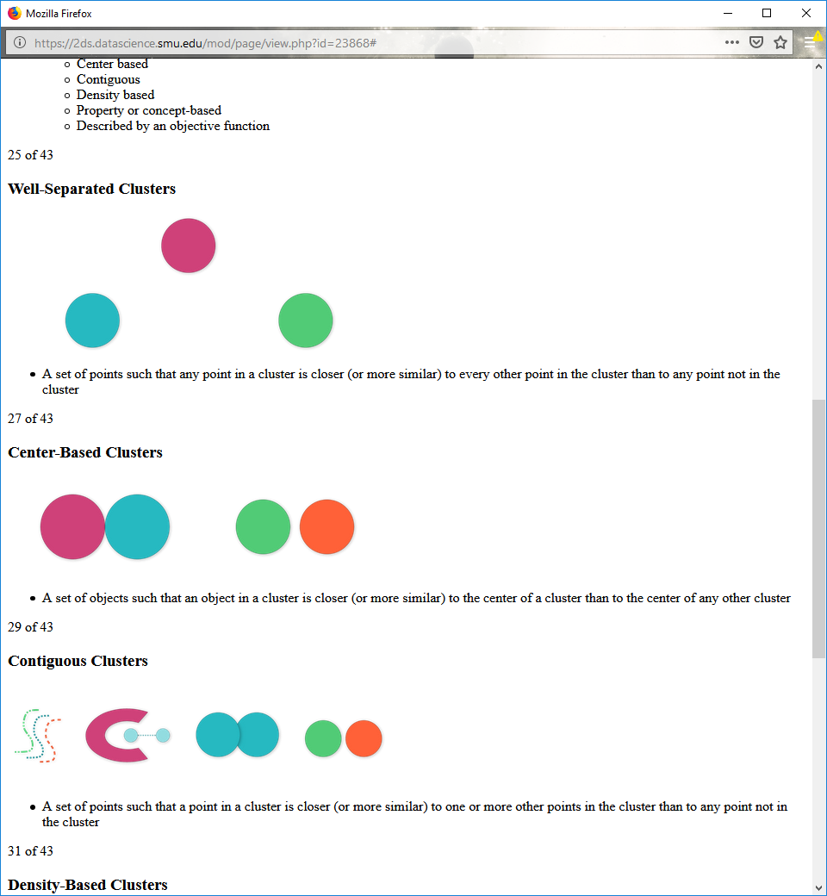

A set of points such that any point in a cluster is closer (or more similar) to every other point in the cluster than to any point not in the cluster

**Center-Based Clusters**



A set of objects such that an object in a cluster is closer (or more similar) to the center of a cluster than to the center of any other cluster

**Contiguous Clusters**



A set of points such that a point in a cluster is closer (or more similar) to one or more other points in the cluster than to any point not in the cluster

**Density-Based Clusters**

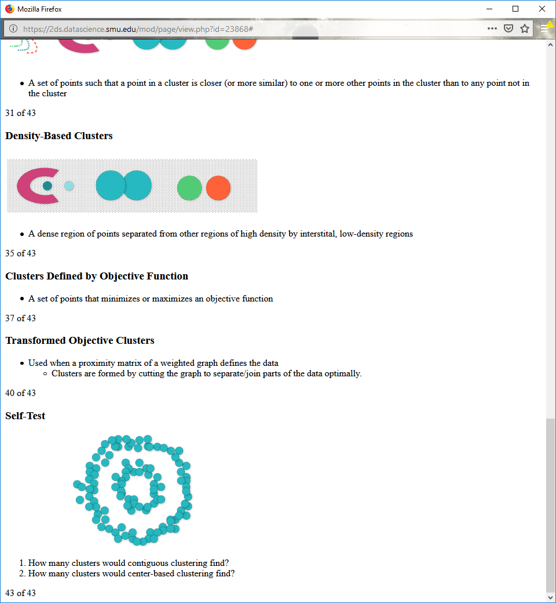

A dense region of points separated from other regions of high density by interstital, low-density regions

**Clusters Defined by Objective Function**

A set of points that minimizes or maximizes an objective function

**Transformed Objective Clusters**

Used when a proximity matrix of a weighted graph defines the data

Clusters are formed by cutting the graph to separate/join parts of the data optimally.

**Self-Test**



1. How many clusters would contiguous clustering find?

2. How many clusters would center-based clustering find?

**10.4**

**K-means Clustering**

Creates partitional clusters that are center based and well separated

Associates each cluster with a **centroid** (center point)

Assigns each point to the cluster with the closest centroid

**K-means Clustering: Algorithm**

|  |  |
| --- | --- |
| 1: | Select *K* points as the initial centroids. |
| 2: | **repeat** |
| 3: | Form *K* clusters by assigning all points to the closest centroid. |
| 4: | Recompute the centroid of each cluster. |
| 5: | **until** The centroids don't change |

**K-means Clustering: Algorithm**

|  |  |
| --- | --- |
| 1: | Select *K* points as the initial centroids. |
| 2: | **repeat** |
| 3: | Form *K* clusters by assigning all points to the closest centroid. |
| 4: | Recompute the centroid of each cluster. |
| 5: | **until** The centroids don't change |

In a single iteration, how many times does each point get accessed in memory?

**K-means Clustering: Complexity**

*O*(*n* × *K* × *d* × *I*)

*n* = number of points

*K* = number of clusters

*I* = number of iterations

*d* = number of attributes

**K-means Clustering: Details**

Initial centroids are often chosen randomly.

Typically, the centroid is the mean of the points in the cluster.

**Closeness** is measured by Euclidean distance, cosine similarity, correlation, etc.

Most of the convergence happens in the first few iterations.

Stopping condition is often changed to "until relatively few points change clusters."

**Two Different K-means Clusterings**

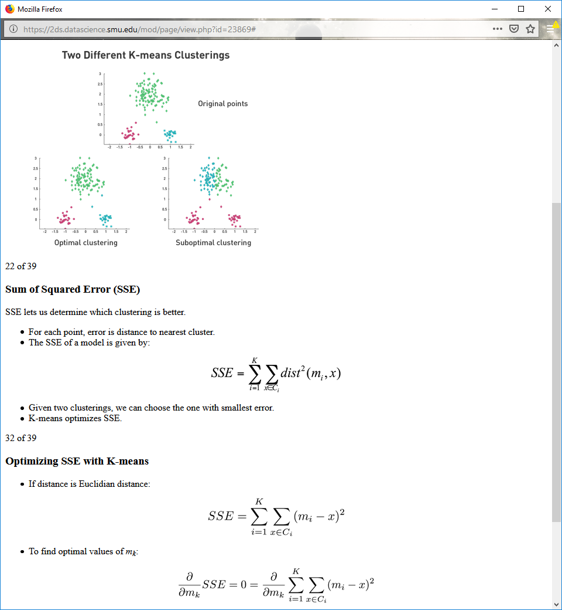

**Sum of Squared Error (SSE)**

SSE lets us determine which clustering is better.

For each point, error is distance to nearest cluster.

The SSE of a model is given by:



Given two clusterings, we can choose the one with smallest error.

K-means optimizes SSE.

**Optimizing SSE with K-means**

If distance is Euclidian distance:



To find optimal values of mk:



**Self-Test**



Solve the equation for the optimal *mk* values.

**Solving Optimization Problem**

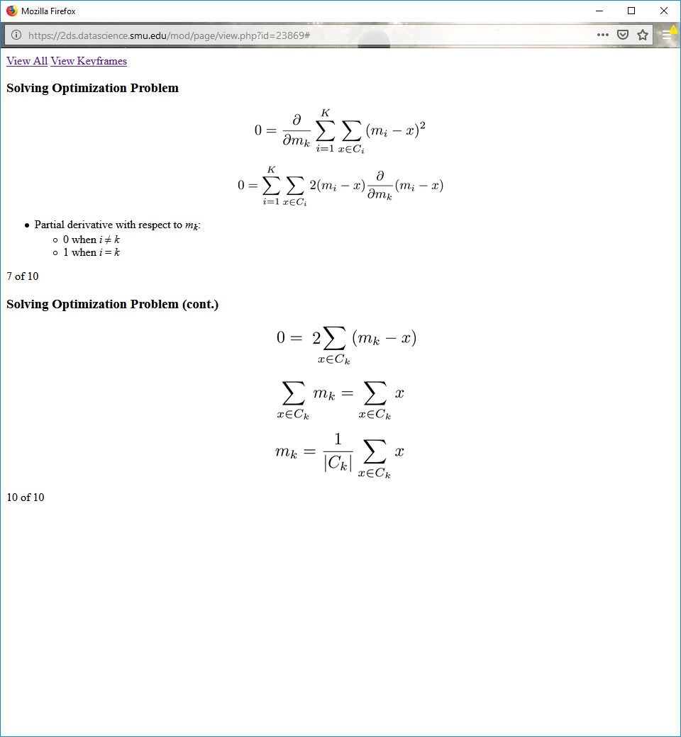

Partial derivative with respect to *mk*:

0 when *i* ≠ *k*

1 when *i* = *k*

**Solving Optimization Problem (cont.)**



**Choosing Initial Centroids**

Very important for K-means

Determines whether result is global or local optimum

**Optimal Clustering**

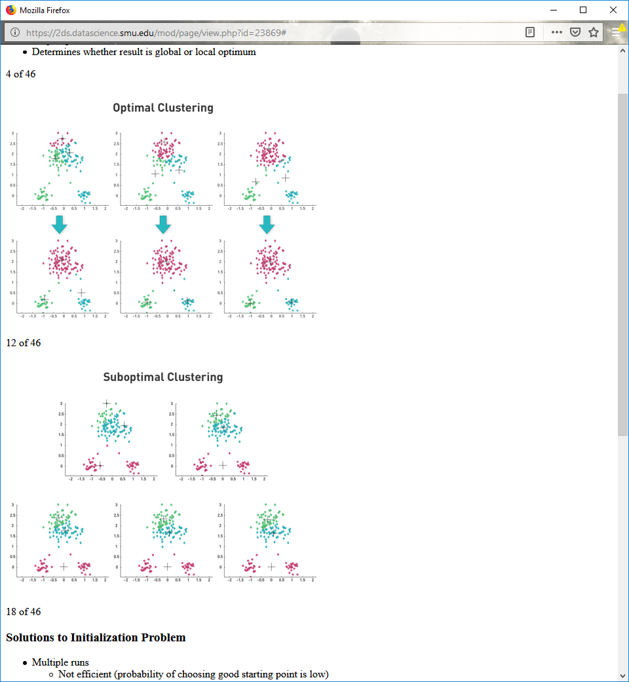

**Suboptimal Clustering**



**Solutions to Initialization Problem**

Multiple runs

Not efficient (probability of choosing good starting point is low)

K-means ++

Selects initial points and initial centroids with more probable selection proportional to distance

Bisecting K-means

Variant of K-means that can produce partitional or hierarchical clustering

**Bisecting K-means Algorithm**

|  |  |
| --- | --- |
| **1:** | Initialize the list of clusters to contain the cluster containing all points. |
| **2:** | **repeat** |
| **3:** | Select a cluster from the list of clusters |
| **4:** | **for** *i* = 1 to *number_of_iterations* **do** |
| **5:** | Bisect the selected cluster using basic K-means |
| **6:** | **end for** |
| **7:** | Add the two clusters from the bisection with the lowest SSE to the list of clusters. |
| **8:** | **until** Until the list of clusters contains *K* clusters |

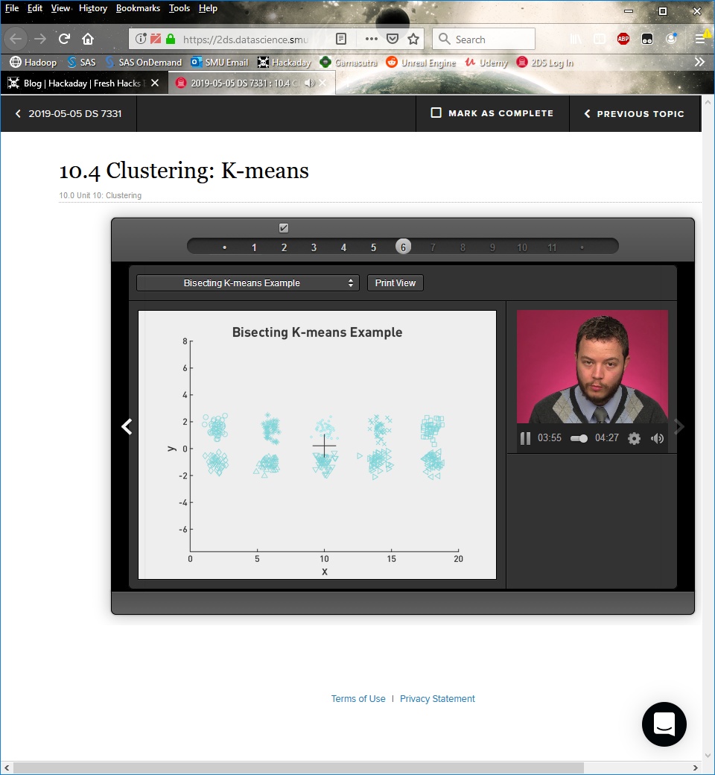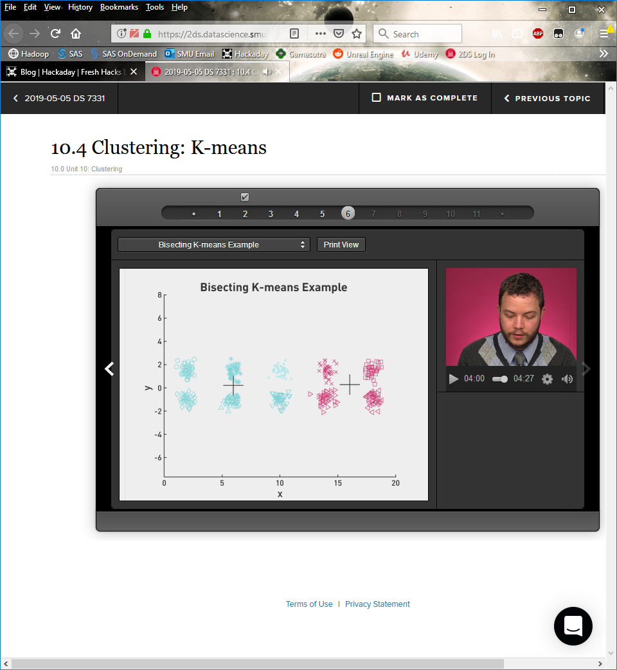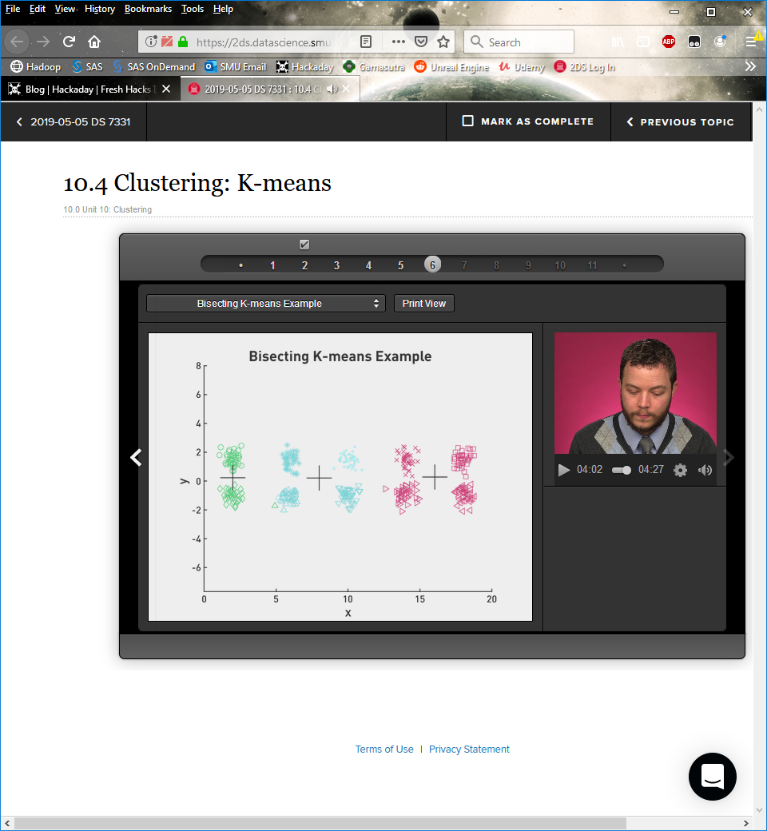

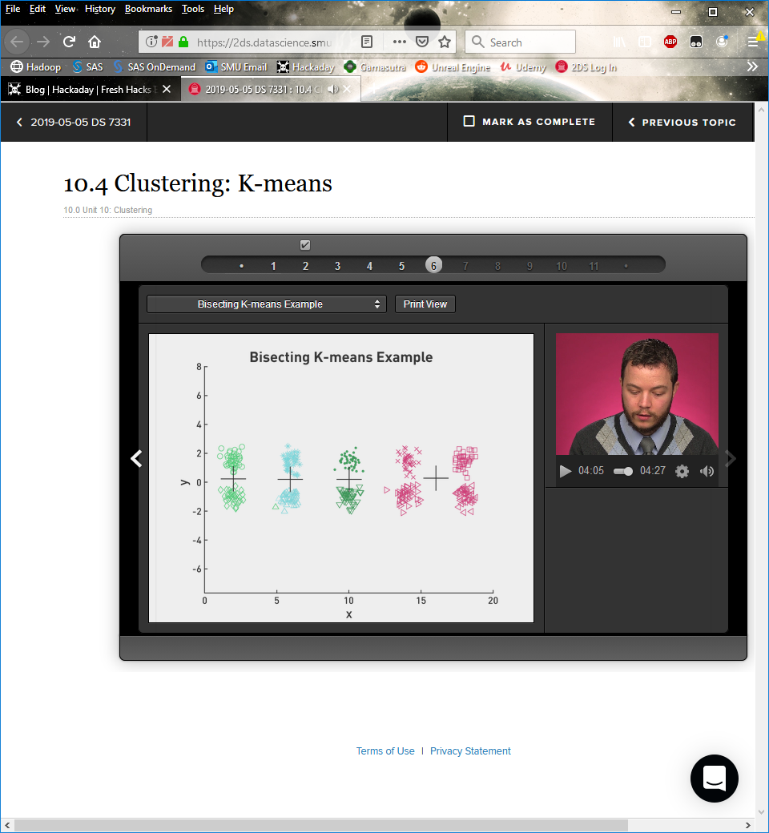**…** 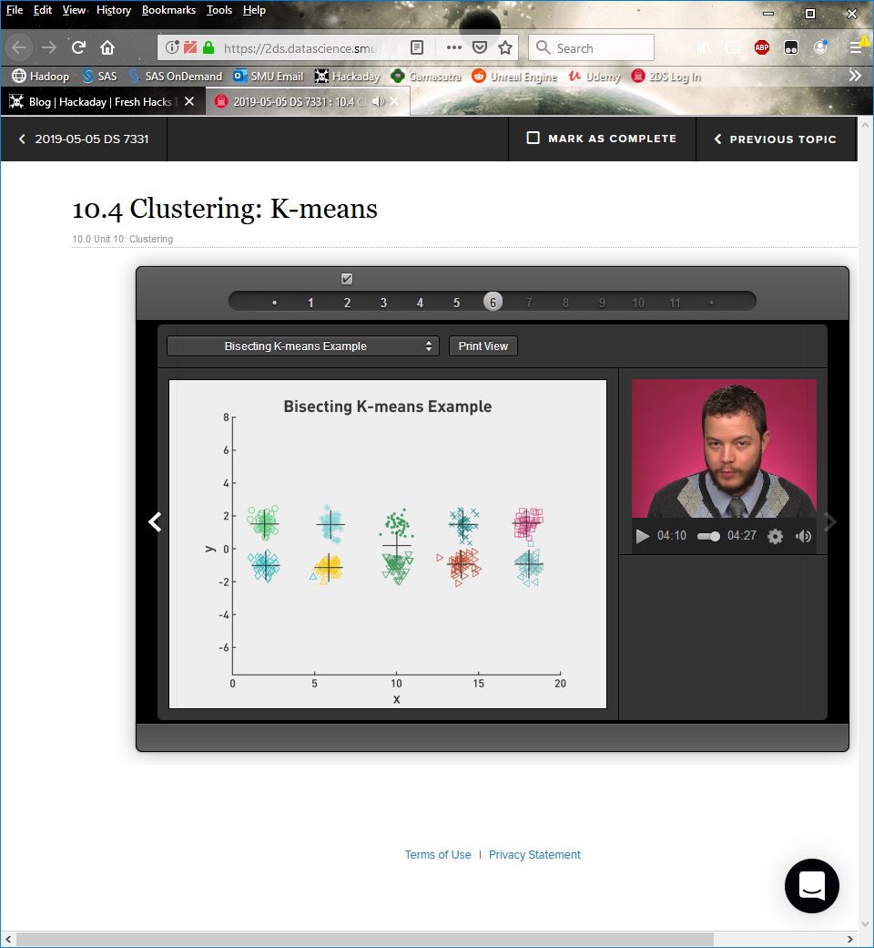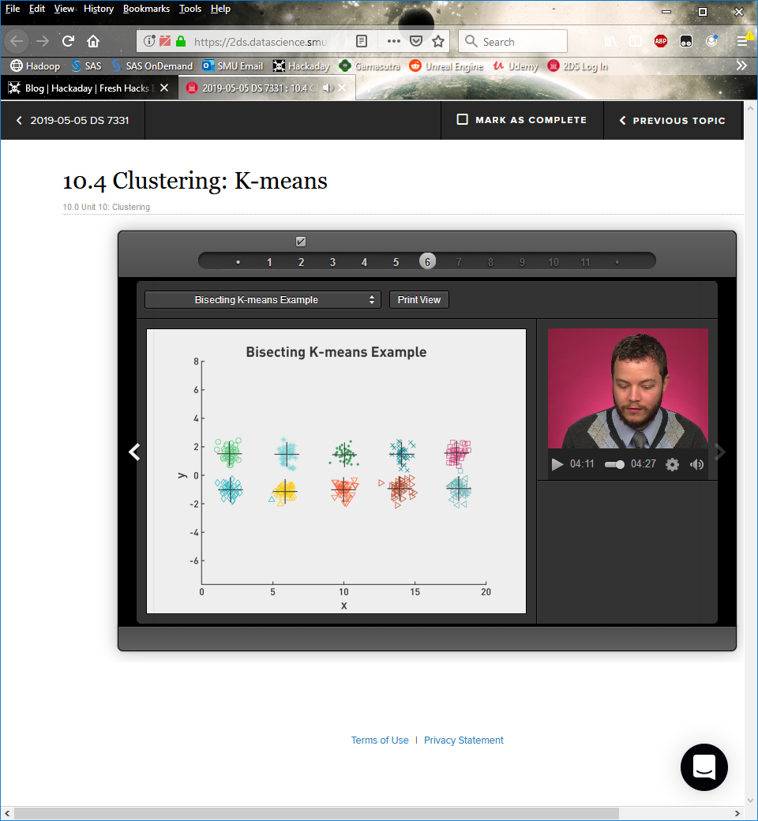

**Self-Test**

|  |  |
| --- | --- |
| **1:** | Initialize the list of clusters to contain the cluster containing all points. |
| **2:** | **repeat** |
| **3:** | Select a cluster from the list of clusters |
| **4:** | **for** *i* = 1 to *number_of_iterations* **do** |
| **5:** | Bisect the selected cluster using basic K-means |
| **6:** | **end for** |
| **7:** | Add the two clusters from the bisection with the lowest SSE to the list of clusters. |
| **8:** | **until** Until the list of clusters contains *K* clusters |

1. Will bisecting K-means always produce the same clustering?

2. Will bisecting K-means always find the *global* minimum squared error solution?

**Complexity of K-means**

*O*(*n* × *K* × *d* × *I*)

Does not scale well as *n* increases

**Updating Centers Incrementally**

Stochastic update

Updates the centroids after each assignment

Fast but erratic

Mini-batch K-means

Randomly selects *x* points at each iteration and updates clusters based on sampling

**Mini-batch K-means Algorithm**

init centers, *c* randomly  
init counts per center, *v*[*c*] = all zeros  
for *t* iterations:  
    choose *M* points from data  
    for each *x* in *M*  
        *c* = closest center to *x*  
        update per center counts: *v*[*c*]++  
        set learning rate *n* = 1/*v*[*c*]  
        update center towards *x*, *c* = (1 − *n*) *c* + *nx*

**K-means Performance Comparison**

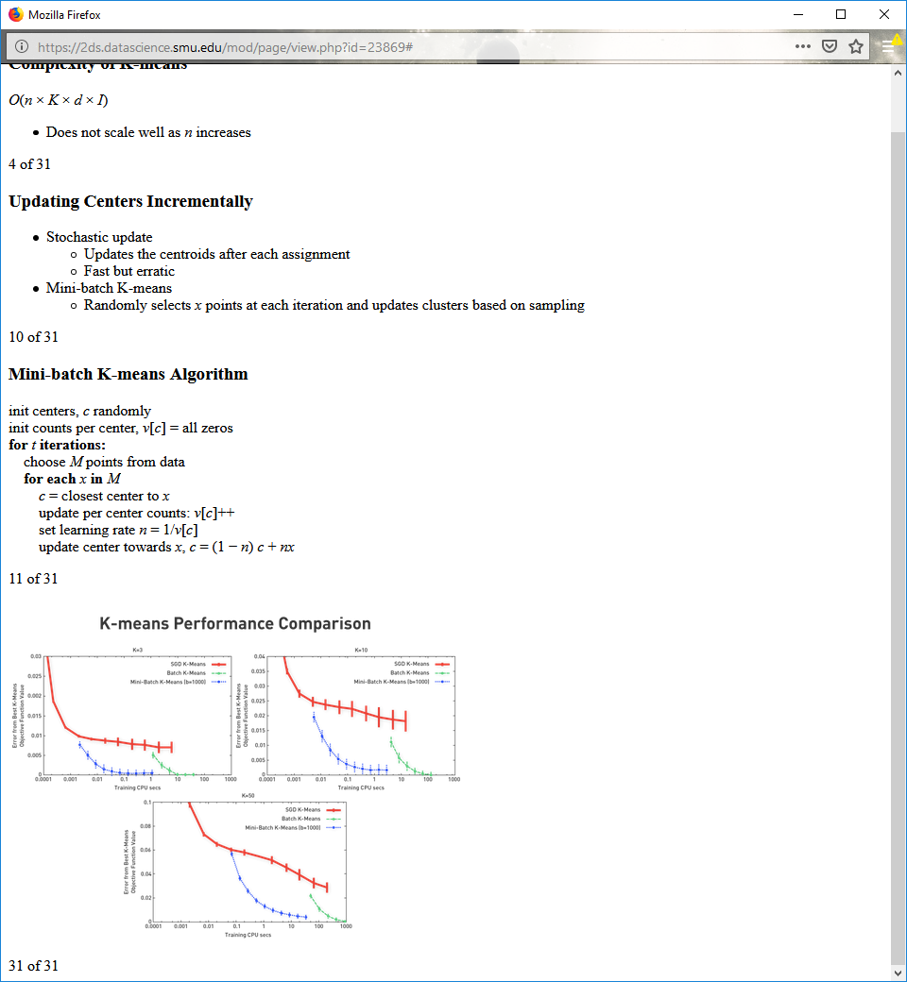

**Limitations of K-means**

K-means encounters problems when:

Clusters are different sizes

Clusters have different densities

Clusters' shapes are nonglobular

**Limitations of K-means: Differing Sizes**

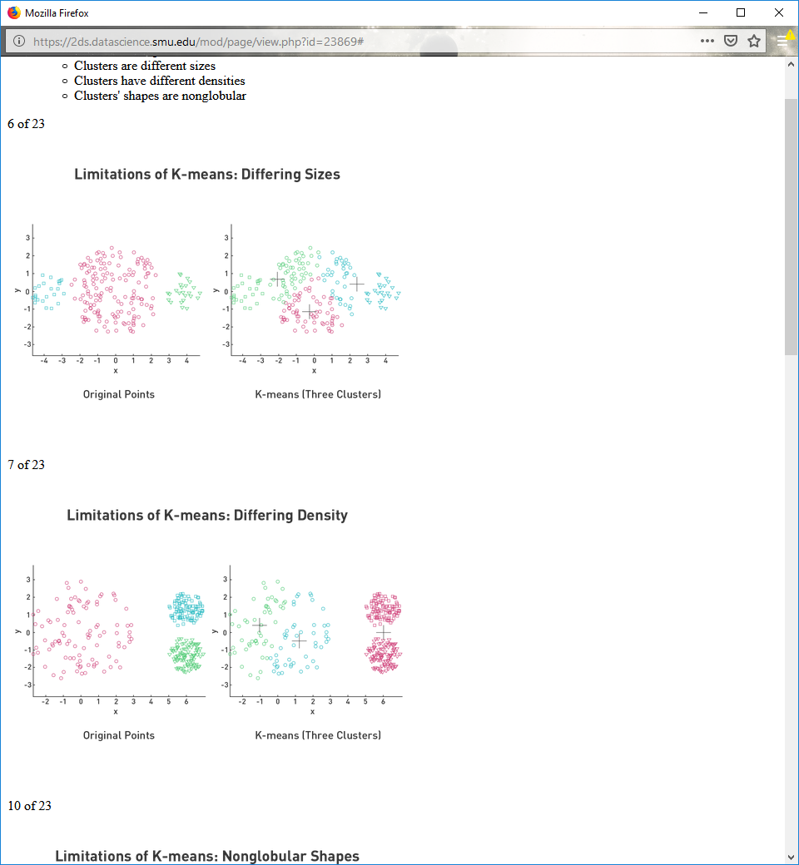

**Limitations of K-means: Differing Density**



**Limitations of K-means: Nonglobular Shapes**

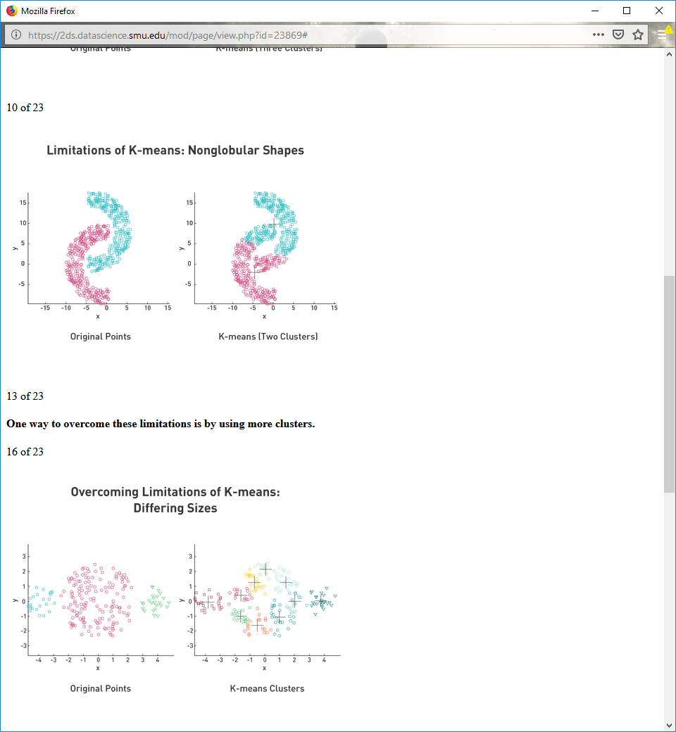

One way to overcome these limitations is by using more clusters.

**Overcoming Limitations of K-means: Differing Sizes**

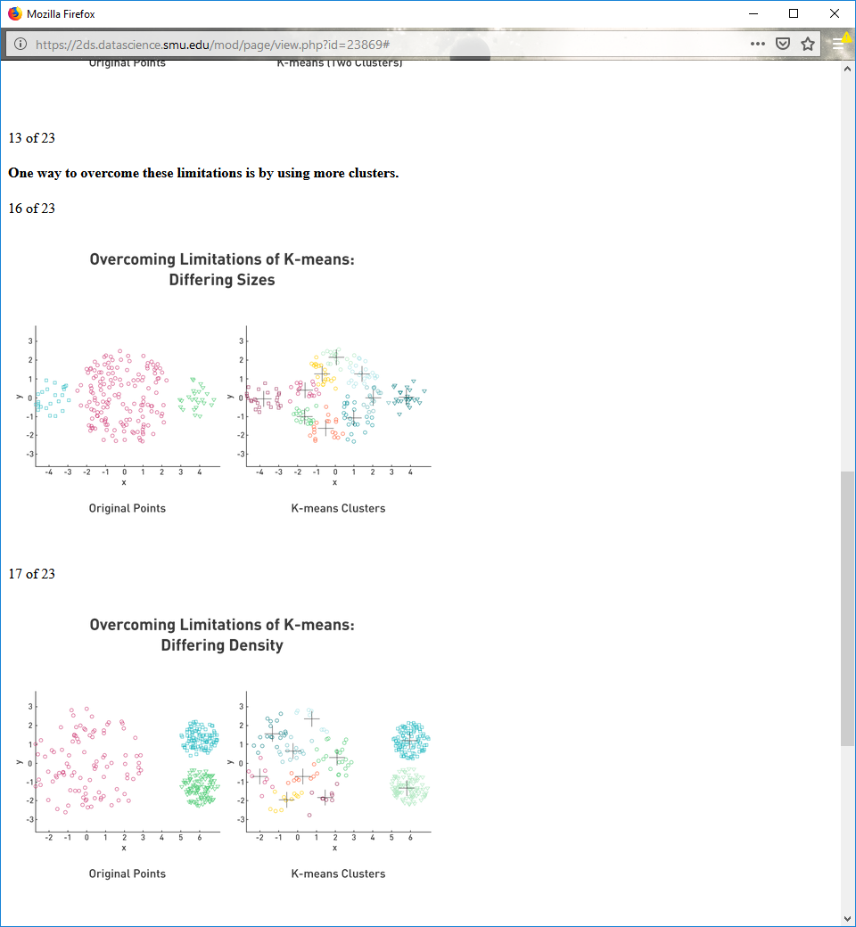

**Overcoming Limitations of K-means: Differing Density**

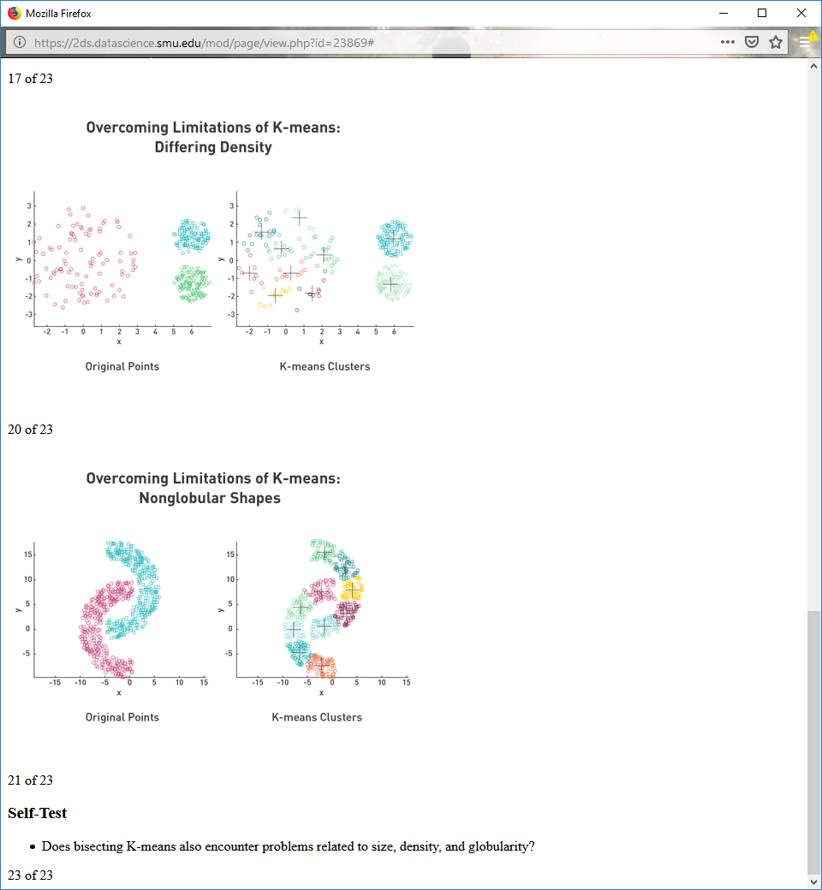

**Overcoming Limitations of K-means: Nonglobular Shapes**



**Self-Test**

Does bisecting K-means also encounter problems related to size, density, and globularity?

**10.5**

**Hierarchical Clustering: Basics**

Produces a set of nested clusters organized as a hierarchical tree

Can be visualized as a dendrogram

**Dendrogram Visualization**

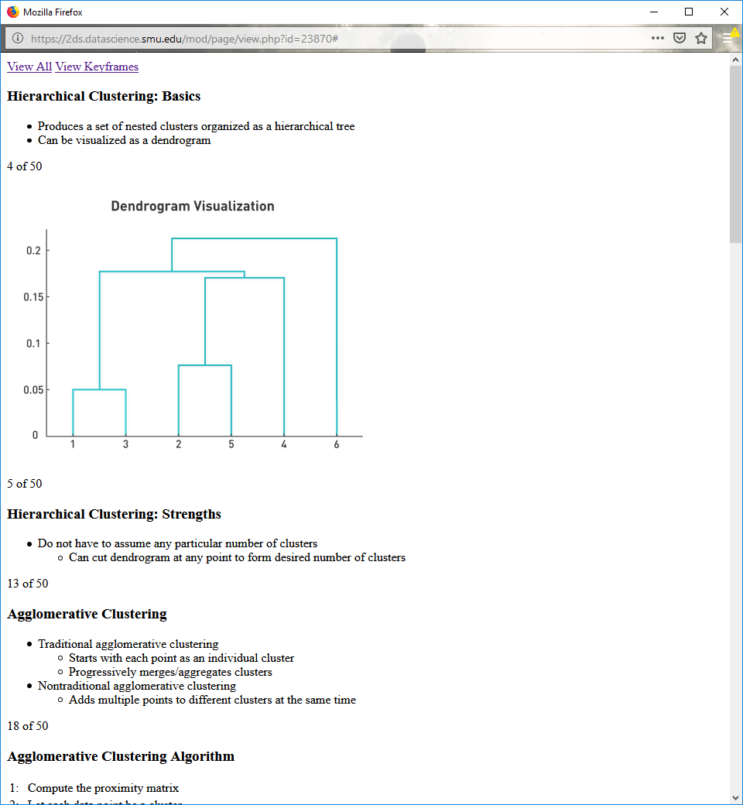

**Hierarchical Clustering: Strengths**

Do not have to assume any particular number of clusters

Can cut dendrogram at any point to form desired number of clusters

**Agglomerative Clustering**

Traditional agglomerative clustering

Starts with each point as an individual cluster

Progressively merges/aggregates clusters

Nontraditional agglomerative clustering

Adds multiple points to different clusters at the same time

**Agglomerative Clustering Algorithm**

|  |  |
| --- | --- |
| 1: | Compute the proximity matrix |
| 2: | Let each data point be a cluster |
| 3: | **Repeat** |
| 4: | Merge the two closest clusters |
| 5: | Update the proximity matrix |
| 6: | **Until** only a single cluster remains |

Key operation: computation of proximity of two clusters

**Computing Cluster Proximity: Starting Situation**

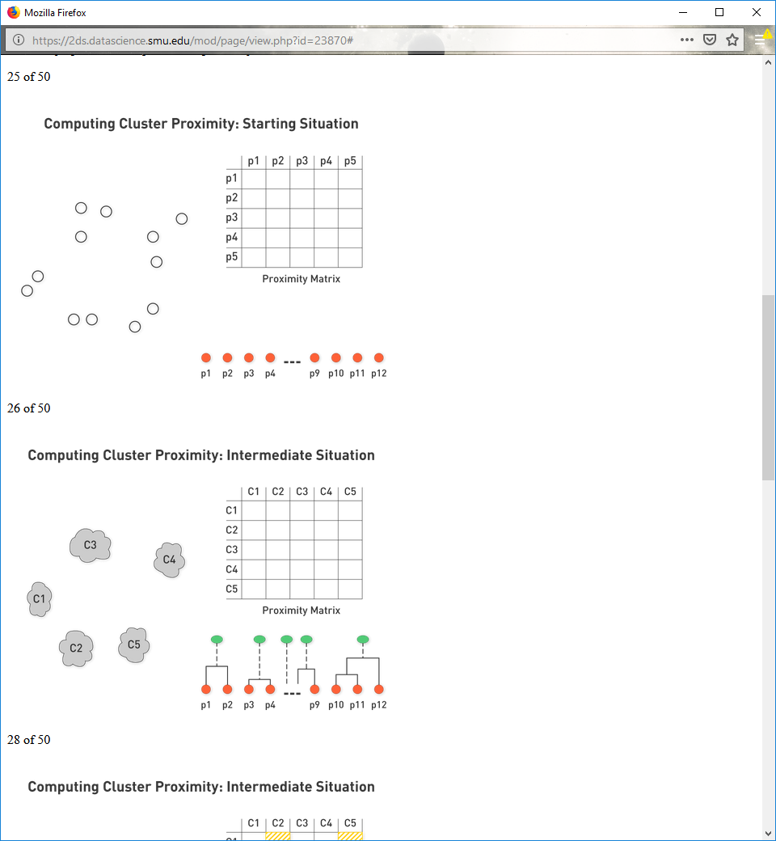

**Computing Cluster Proximity: Intermediate Situation**



**Computing Cluster Proximity: Intermediate Situation**

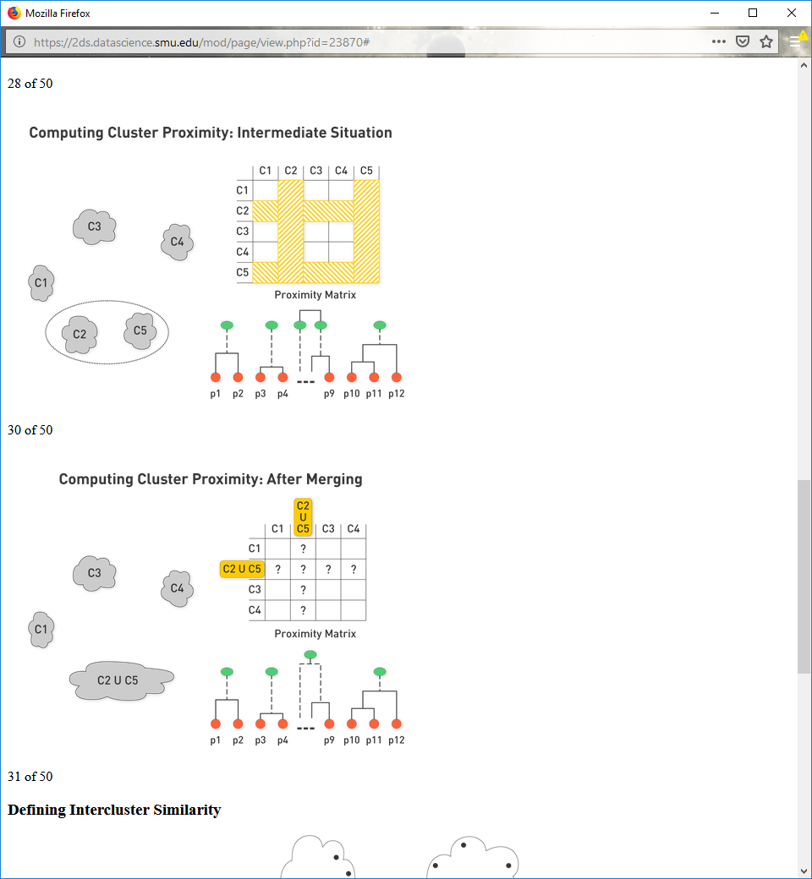

**Computing Cluster Proximity: After Merging**



**Defining Intercluster Similarity**

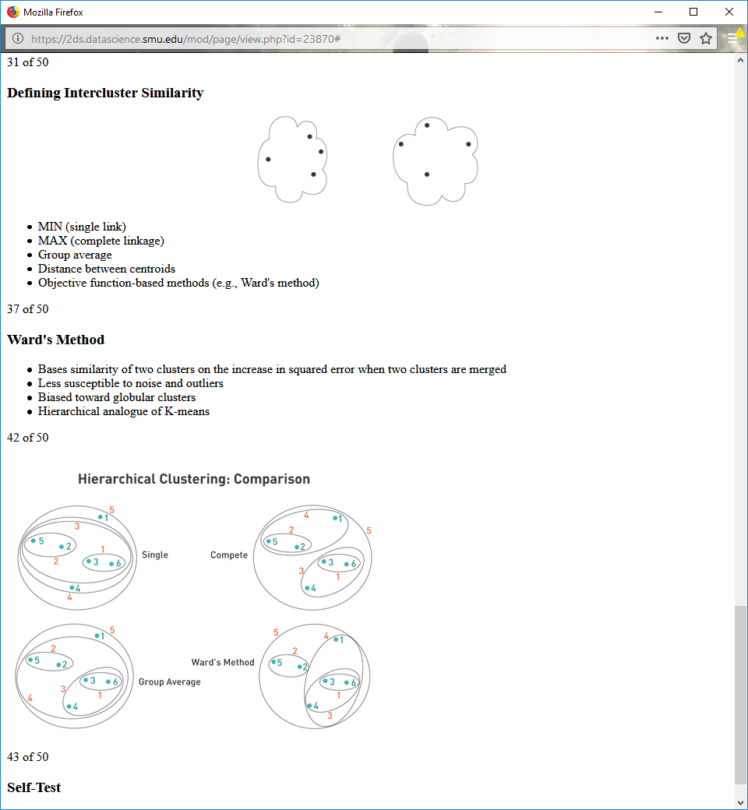

MIN (single link)

MAX (complete linkage)

Group average

Distance between centroids

Objective function-based methods (e.g., Ward's method)

**Ward's Method**

Bases similarity of two clusters on the increase in squared error when two clusters are merged

Less susceptible to noise and outliers

Biased toward globular clusters

Hierarchical analogue of K-means

**Hierarchical Clustering: Comparison**



**Self-Test**

Draw the dendrograms for complete linkage and Ward's method.

**Hierarchical Clustering: Drawbacks**

Requires O(N2) space to store proximity matrix

Computationally complex (complexity is O(N3) in many cases)

Proximity matrix (whose size is N2) is updated and searched at each of N steps

Complexity can be reduced to O(N2 log(N)) using kd-trees

Cannot undo decision to combine two clusters

Does not directly minimize any objective function

**Dealing with Limitations**

Different schemes have problems with:

Sensitivity to noise and outliers

Handling different sized clusters and convex shapes

Breaking up large clusters

**10.6**

**DBSCAN: Density-Based Algorithm**

**Core point:** point that has more than a specific number of points (MinPts) within a specified radius (Eps)

**Border point:** point that has fewer than MinPts within Eps but is in the neighborhood of a core point

**Noise point:** any point that is not a core or border point

**Core, Border, and Noise Points**

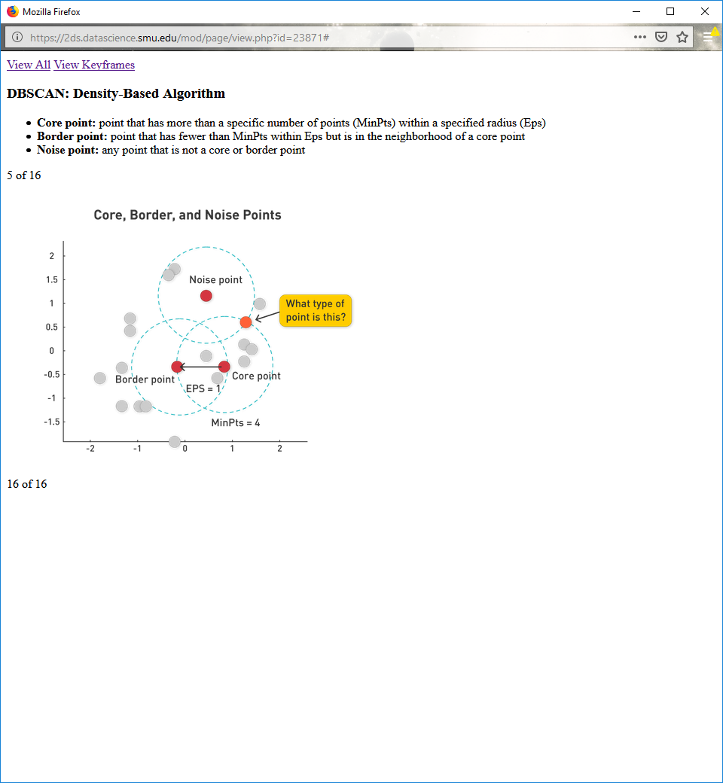

**DBSCAN Algorithm Pseudocode**

current_cluster_label ← 1  
**for** all core points **do**  
    **if** the core point has no cluster label **then**  
       current_cluster_label ← current_cluster_label + 1  
       Label the current core point with cluster label current_cluster_label  
    **end if**  
    **for** all points in the Eps-neighborhood, except ith the point itself **do**  
       **if** the point does not have a cluster label **then**  
           Label the point with cluster label current_cluster_label  
       **end if**  
    **end for**  
**end for**

**DBSCAN Algorithm**

Run after labeling core, border, and noise points

Labels unlabeled core points

Connects all core points within Eps

**DBSCAN Visualized**

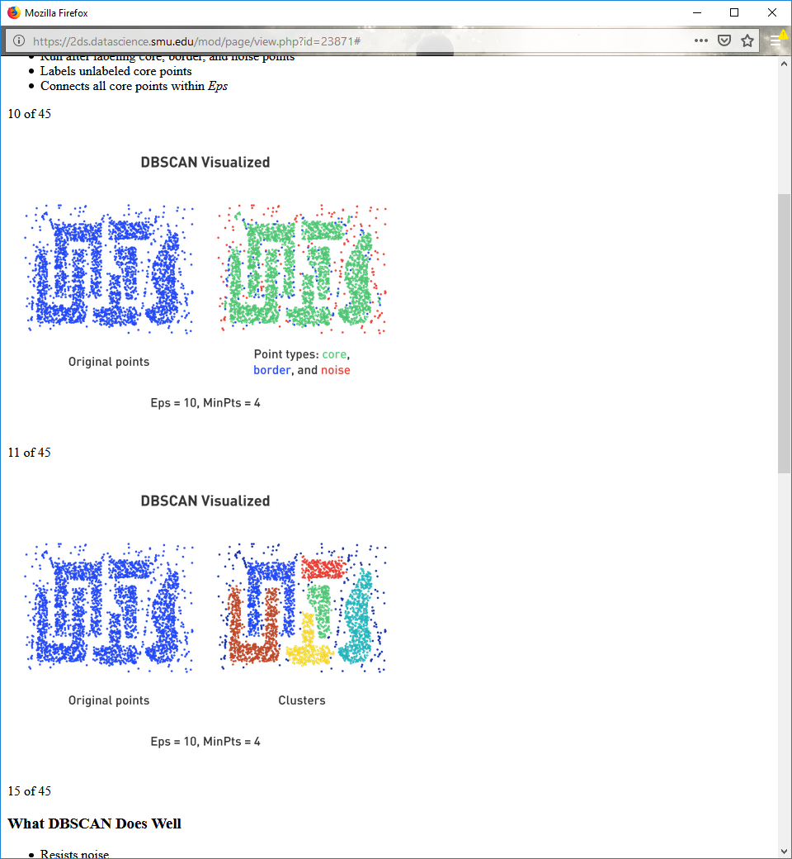

**DBSCAN Visualized**



**What DBSCAN Does Well**

Resists noise

Handles clusters of different shapes and sizes

**When DBSCAN Does Not Work Well**

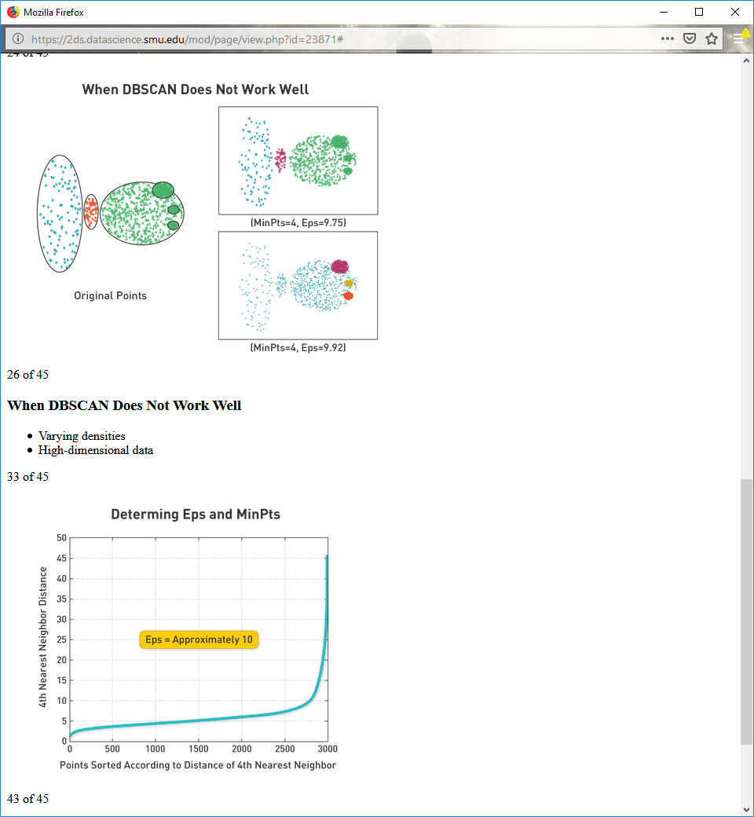  
**When DBSCAN Does Not Work Well**

Varying densities

High-dimensional data

**Determing Eps and MinPts**



**Determining Eps and MinPts**

Eps:

Calculate Kth nearest neighbors for all points in data set.

Save distance of farthest neighbor.

Plot sorted distance of every point to its Kth nearest neighbor.

MinPts

Set to four (works well, empirically).

**10.7**

Just writing code

https://github.com/eclarson/DataMiningNotebooks

**10.8**

**Cluster Validity Estimation**

Measures "goodness" of created clusters

Is inherently subjective

Takes the following approaches

Determines clustering tendency of a data set

Compares results of cluster analysis to externally known results

Evaluates how well results of cluster analysis fit data without reference to external information

Compares results of two different sets of cluster analysis

Determines "correct" number of clusters

**Visual inspection: Similarity Matrix**

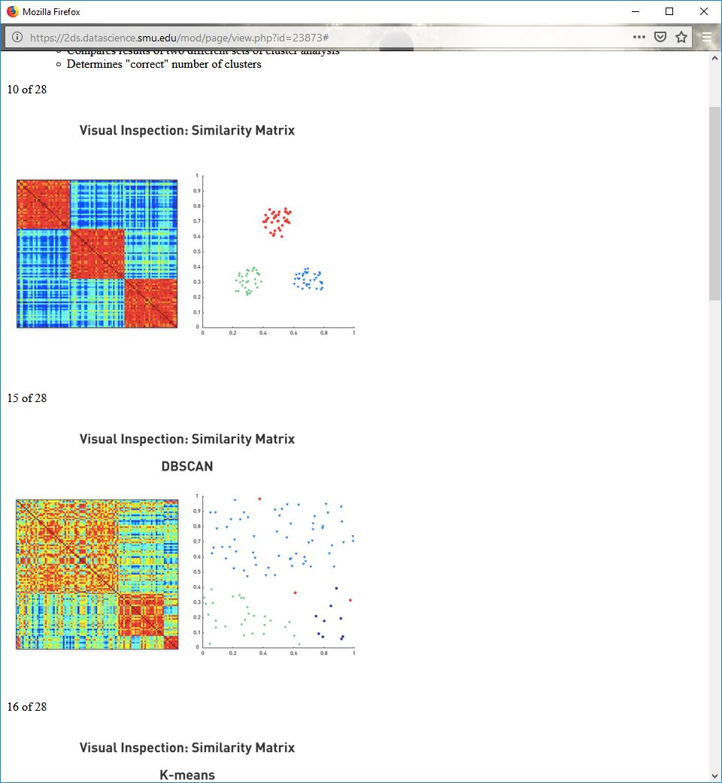

**Visual inspection: Similarity Matrix**

 Clusters have ill defined edges, looks a bit random

**Visual inspection: Similarity Matrix**

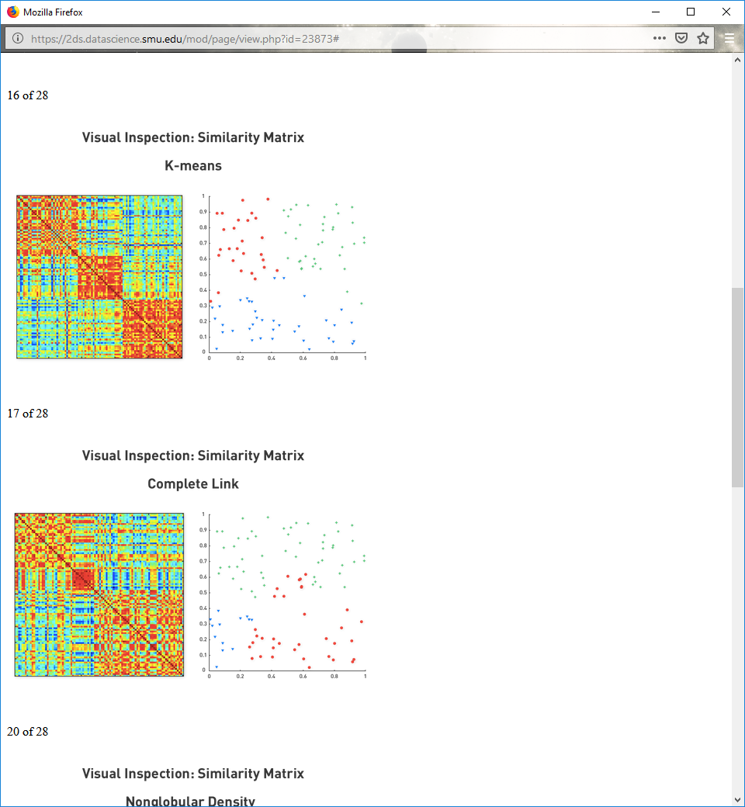

second and third clusters have a bit of globularity, but top left seems pretty random

this one seems better than the other 2

**Visual inspection: Similarity Matrix**



**Visual inspection: Similarity Matrix**

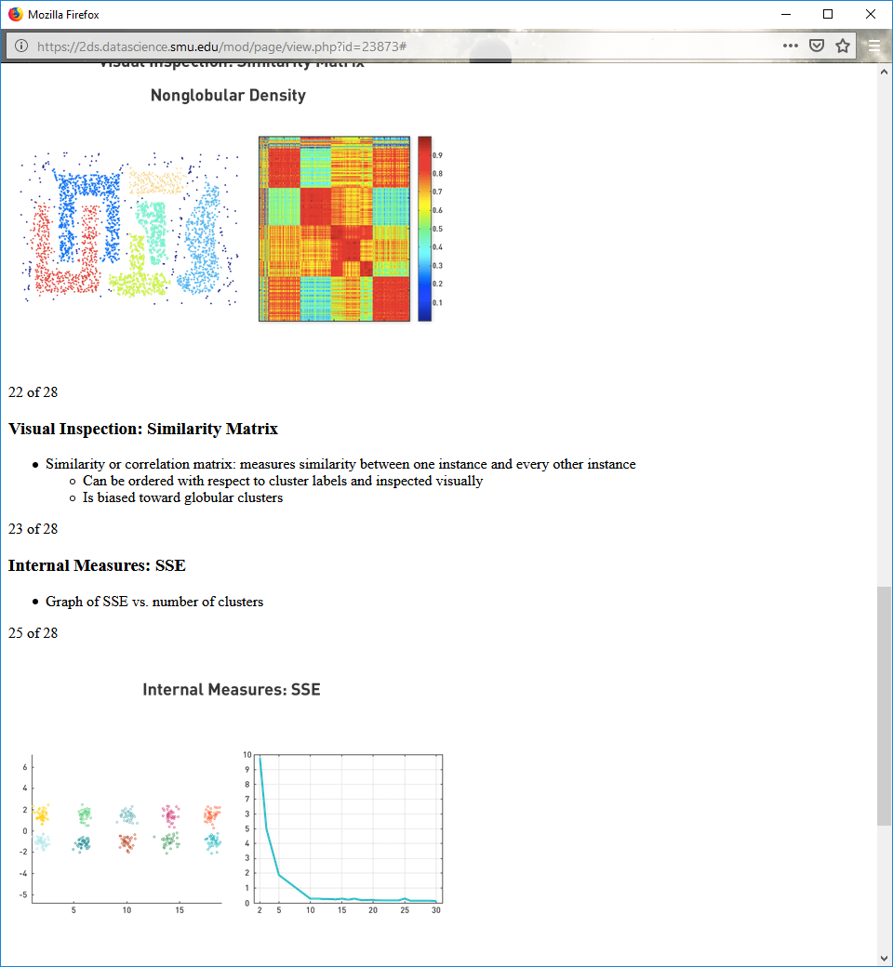

**Visual Inspection: Similarity Matrix**

Similarity or correlation matrix: measures similarity between one instance and every other instance

Can be ordered with respect to cluster labels and inspected visually

Is biased toward globular clusters

**Internal Measures: SSE**

Graph of SSE vs. number of clusters

**Internal Measures: SSE**

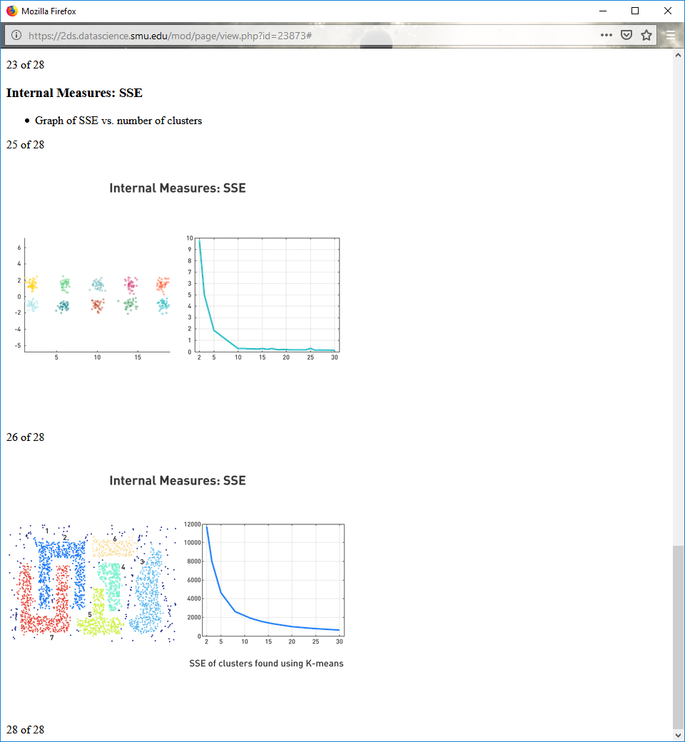

**Internal Measures: SSE**



**Cohesion and Separation**

**Cluster cohesion** measures how closely related objects are in a cluster.

Within-cluster sum of squares:

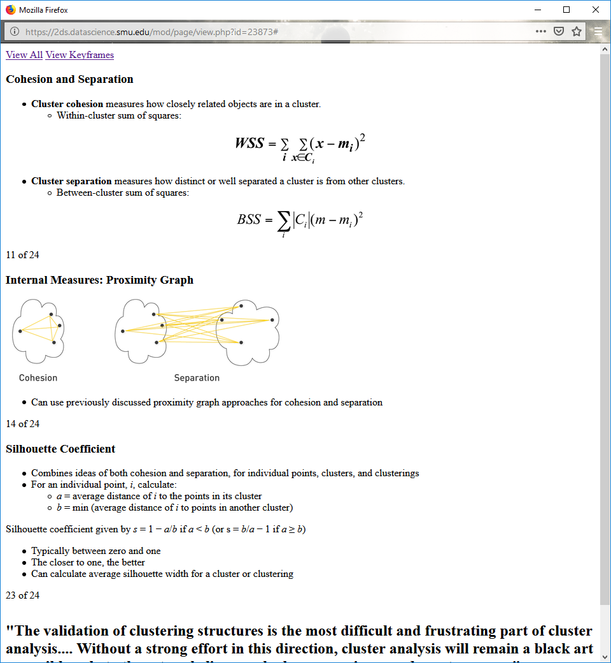

**Cluster separation** measures how distinct or well separated a cluster is from other clusters.

Between-cluster sum of squares:



**Internal Measures: Proximity Graph**



Can use previously discussed proximity graph approaches for cohesion and separation

**Silhouette Coefficient**

Combines ideas of both cohesion and separation, for individual points, clusters, and clusterings

For an individual point, i, calculate:

a = average distance of i to the points in its cluster

b = min (average distance of i to points in another cluster)

Silhouette coefficient given by s = 1 − a/b if a < b (or s = b/a − 1 if a ≥ b)

Typically between zero and one

The closer to one, the better

Can calculate average silhouette width for a cluster or clustering

"The validation of clustering structures is the most difficult and frustrating part of cluster analysis.... Without a strong effort in this direction, cluster analysis will remain a black art accessible only to those true believers who have experience and great courage."